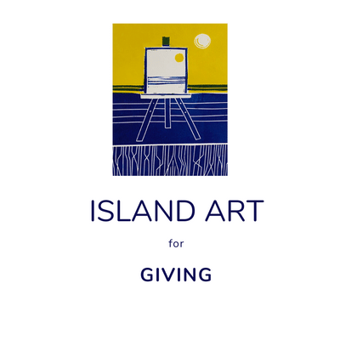
ARTWORK SUBMISSION FORM
Please fill in the following information and include it when submitting your artwork.
Deadline for submission – 30th April 2020
Name ……………………………………………………………………………………………………………………………………………….
Address ……………………………………………………………………………………………………………………………………………
…………………………………………………………………………………………………………………………………………………………
Telephone number …………………………………………………………………………………………………………………………..
Email address …………………………………………………………………………………………………………………………………..
Website address (if applicable) ………………………………………………………………………………………………………..
Please add some information about yourself and your art practice if you would like this displayed on the online gallery. (use another sheet)
Picture number | Title of artwork | Description of artwork (e.g. watercolour on paper, oil on card etc)

You may donate a maximum of 3 pieces of artwork. Please number each one on the back and also please draw an arrow on the back to indicate the top of the picture, as the orientation is not always obvious. Many thanks.
Please send your work to: Gill Thompson, Harbour Print, 22c Vatisker, Isle of Lewis, HS2 0JS
· image size 6” x 4” (approximately 15.3cm x 10.2cm) on card/board/paper sized
7” x 5” (approximately 17.8cm x 12.7cm)
· signed on the front
· unmounted

All work will become the property of West Harris Trust upon donation. Although the artist retains copyright. West Harris Trust will be free to reproduce selected images for publicity purposes. Unsold work may be exhibited again or used for publicity in the future, as part of our on-going campaign to raise funds.

